How can I view my support tickets?

1. Sign into the support center by clicking the "Sign In" button on the top right hand corner
   1. 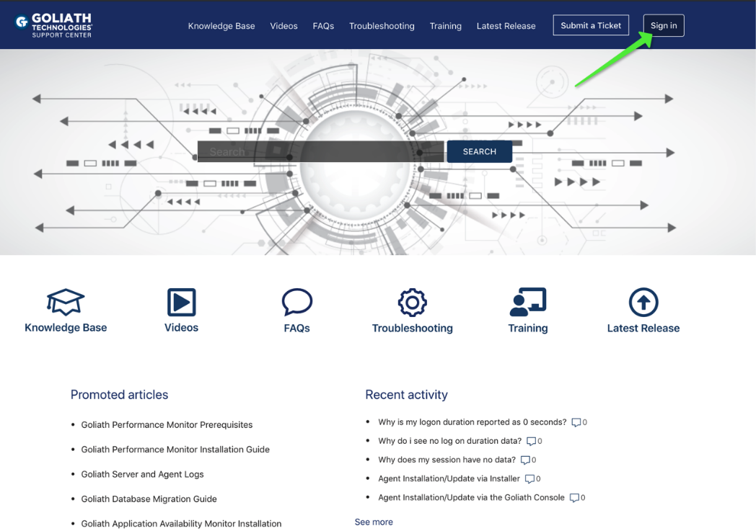
2. Once you are signed in, click on the username link in the top right hand corner to present a drop down menu
   1. 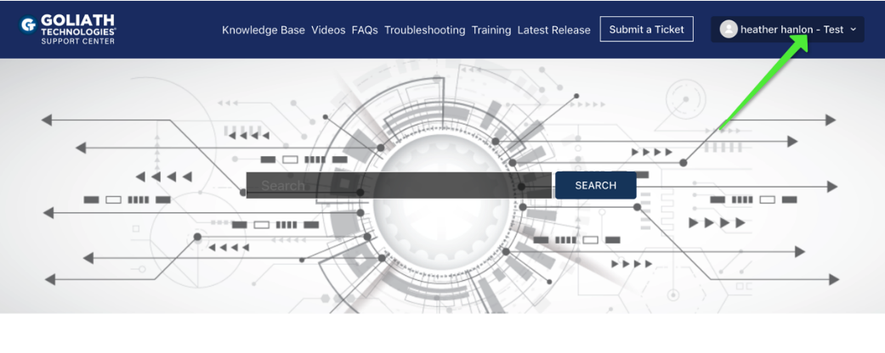
3. On the drop down menu choose the option for "my activities"
   1. 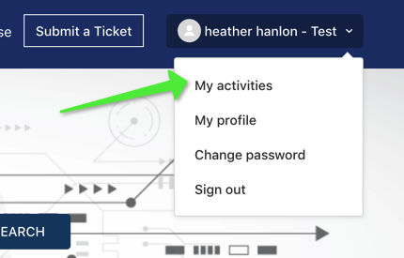
4. This will take you to the "My Request" page, by default this will list out of the tickets you have opened yourself.
   * 1. You can see tickets the tickets subject, number and status.
     2. If the status is "solved" this means the ticket has been closed.
     3. If the status is "open" this means that is under review by the Goliath Support Team.
     4. If this status is "awaiting your reply" this means that a Goliath Support Engineer has replied to your ticket and waiting for a response.
   1. You can click on any of the subject links to see the full communication chain for each ticket.
      1. When a ticket is "open" or "awaiting your reply" you can add additional comments or upload additional materials as needed.
   2. 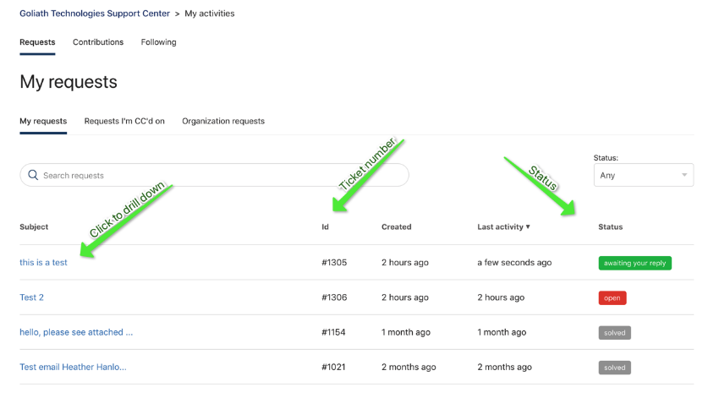
5. In addition to viewing your requests, you can also see the tickets you are "cc'd" on, as well as any tickets open for your organization.

